Annual GOS Complaints Submission: 2022/23 and 2023/24
National Briefing – April 2024

Dear Colleague,

As you will be aware it is a contractual requirement to confirm the number of written NHS complaints received for GOS in your practice. NHSBSA are administering the GOS complaints submission on behalf of GOS commissioners. We are writing to confirm with you the dates and process for this year’s submission.

The online data submission will be open between Monday 20th May 2024 to Sunday 16th June 2024. Access to the survey will require you to input your ODS code. If you are unsure of your code, you can look up your practice using NHS Digital’s ODS Portal.

You can submit your complaints data online, detailing any NHS complaints received within the 2022/2023 and the 2023/2024 financial years.

You can also access the form by scanning the QR code below:

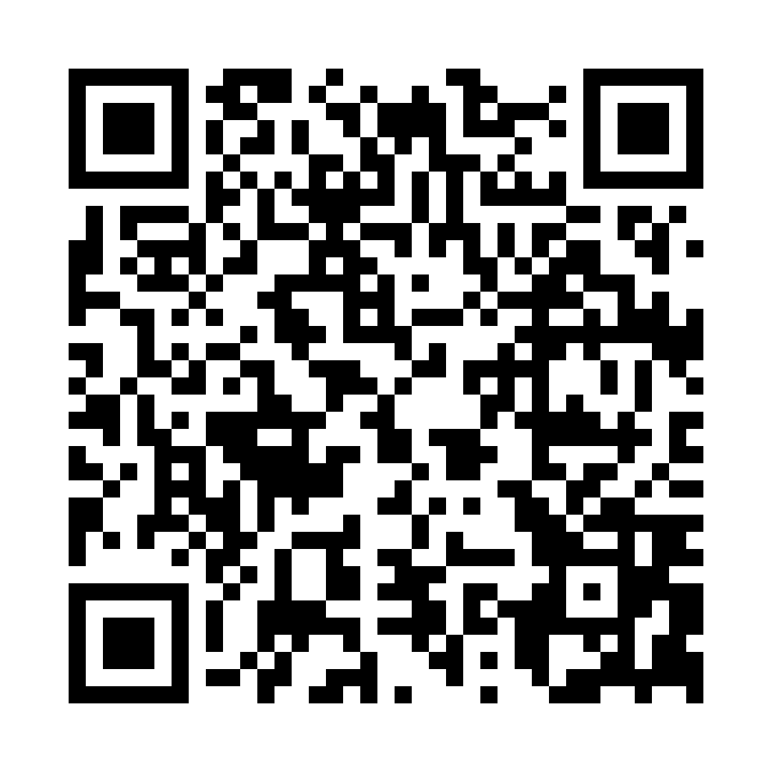

Alternatively, the submission can be accessed via the Provider Assurance Ophthalmic website.

Your response will be collated along with responses from fellow GOS contractors and shared with the commissioner.

Should you have any queries, please contact the Provider Assurance Ophthalmic team via e-mail at: pao@nhsbsa.nhs.uk

Our core opening hours are Monday to Friday, 8.00am – 4.30pm.

Thank you,

Provider Assurance Ophthalmic team

